Activity #2: Component Selection

After finishing Activity #1, you are ready to start selecting different components! When selecting components, please follow the LV Standards guideline to picking different form factors. Typically, our resistors and capacitors are both 0603, but this is just a general guideline. Typically do not go under 0603, but if we need a larger voltage rating, going up is completely fine. We typically only source from Digikey as well (Mouser if it is the only place available). We also do not want to use marketplace products. These are all filters that you can apply on Digikey, and more information is available in the LV standards document.

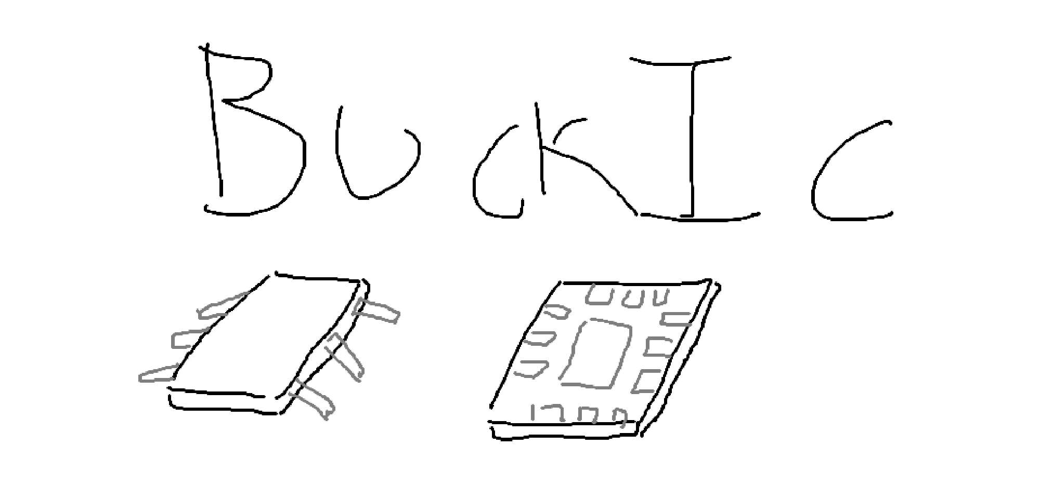

The first big thing to source is your Buck IC! This chip is used to adjust the duty cycle of the switches, and work with the feedback loop. For reference, here is the one we used last year but is now out of stock. The big thing is making sure it can output enough current to supply our boards! For FS5, we defaulted to a 2A buck, which worked perfectly fine (to my knowledge), so anything 2A and above is good! However, be sure to properly select this, because there are some tradeoffs that you may have to make if you oversize the buck converter too much. Feel free to ask me if you have any questions about that!

There are a couple I have in mind, but I would like you guys to do your own research and play with Digikey to be more familiar with the website! This is where we order almost all our parts, excluding some from Mouser. You will need to get familiar with it. Here are some initial parameters to get you all started on looking.

Input Voltage | ~10-15V *
Output Voltage | 5V
Output Current | Iout $≥$ 2A
Switching Frequency | Fsw $≥$ 500kHz**
Feedback Control | 😳
Ripple Voltage | 1-5%
*Though our LV bus is 12V nominally, it is actually 13.5V!
**with too low of a switching frequency, you upsize your inductor and output capacitor value, which could be an issue space wise. This is an arbitrary value I have set for the case of the onboarding project.

Whatever chip you decide to pick, be sure to properly read the entire thing, understanding what each pin does, what kind of internal structure it has, and the reasoning behind all of it.

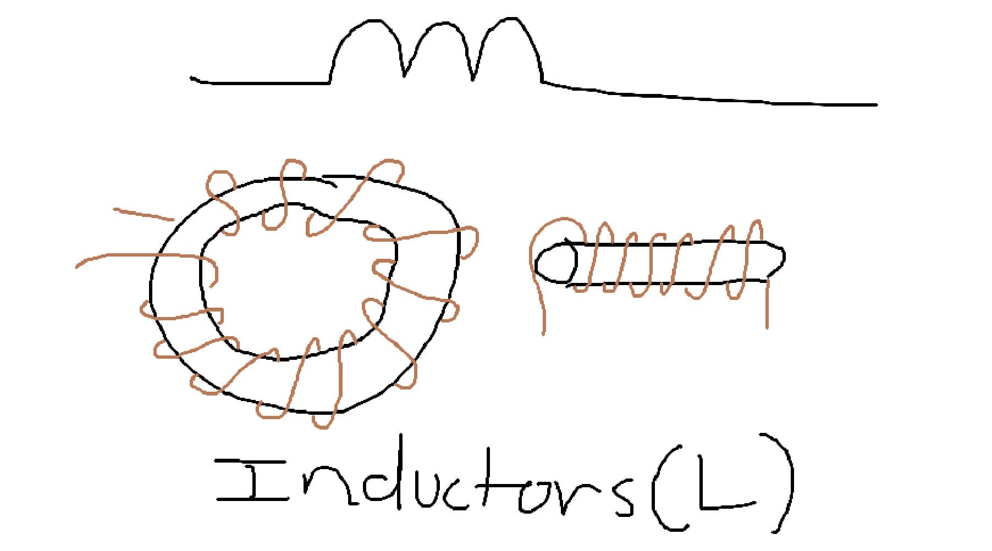
One big thing you should check in an inductor is its saturation current. Make sure that your inductor does not oversaturate at the output current you are expecting, or else your inductor’s inductance will drop so low that your output ripple will be extremely large.

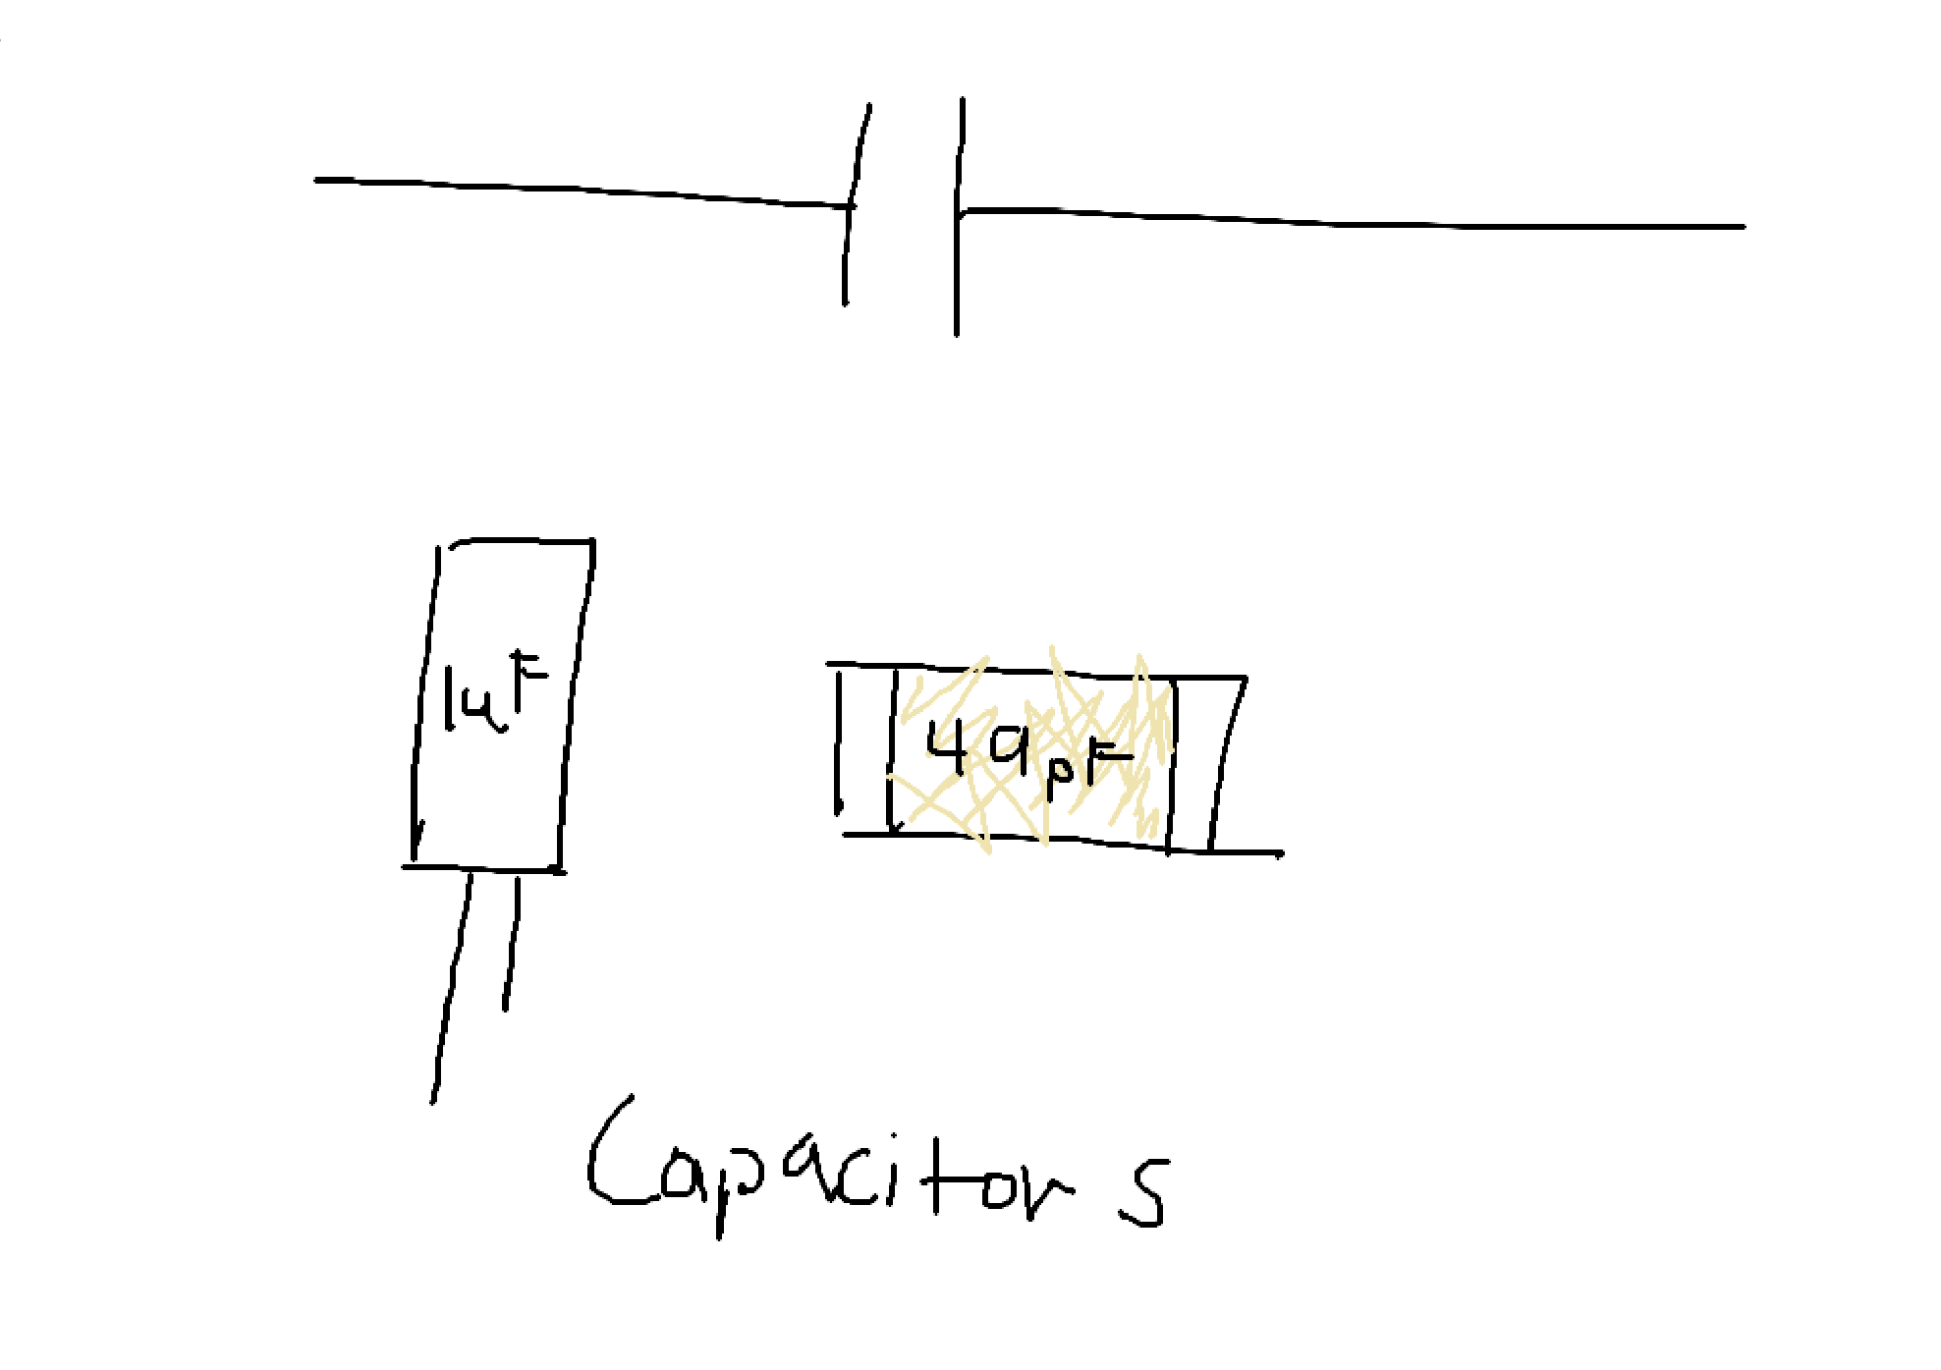
Capacitors have a funny little thing called DC Biasing. Capacitors do not like staying at the specific capacitance they were designed to be at. Instead, whenever you apply any kind of voltage across one, their capacitance will drop by some percentage, typically shown in your datasheet. Make sure that your capacitances will be what you are expecting at your expected output voltage! A little hint: The output capacitors are there to help filter noise! There is something you have to do when picking your output capacitors to help reduce noise on the output end.

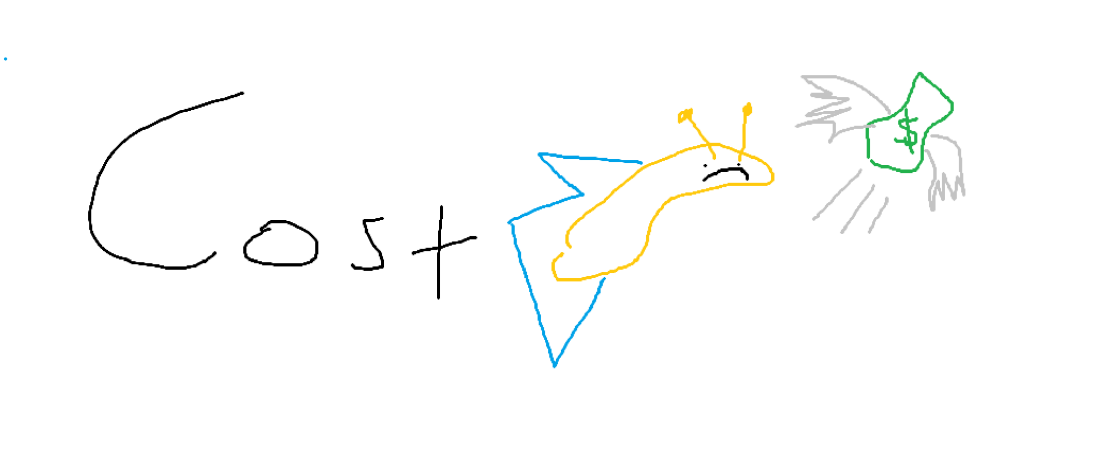
Make sure to try to minimize costs as much as possible! This is more of a good engineering practice to not just go with the best thing if it costs an unreasonable amount of money.

At the end of this activity, fill out this chart with the things that you have selected for ONE buck converter, with the costs per unit and size as well. If you need to add more rows, feel free to.

Component | Cost | Units Available | Size | Link
Buck IC | 1 unit: $2.14 | 1920 |  | https://www.digikey.com/en/products/detail/texas-instruments/TPS5405DR/3478075
L
Cboot |  |  |  | https://www.digikey.com/en/products/detail/kemet/C0603C104K5RACTU/1465594
Co
Cin
Css
Cc
Rosc
Rc
Total Cost

https://www.ti.com/lit/ds/symlink/tps5405.pdf?ts=1791646957617
Formulas for the necessary values
- These formulas are found pages 8-11
- File with math can be found in the PE folder in Github
Component | Calculated Value | Purchased value
L | 9.72microH
Cboot | 0.1microF | 0.1microF
Co | 80microF
Cin | 20microF
Css | 5nF
Cc | 2.2nF
Rosc | 48.9kOhms
Rc | 82kOhms

